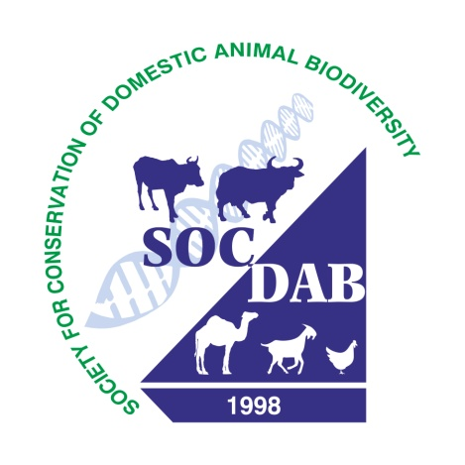

Invitation of applications for SOCDAB-FELLOW (2026)
and
XX Annual Convention/ National Symposium, SOCDAB

Dear Sir/ Madam,

Applications are invited from the Life-Members of the Society of Conservation of Domestic Animal Biodiversity (SOCDAB) for the award SOCDAB-FELLOW (2025). The SOCDAB-FELLOW award will be conferred to an individual scientist during the ‘‘XX Annual Convention of Society for Conservation of Domestic Animal Biodiversity (SOCDAB)-2026 on “Scientific and Community-led Approaches for Sustainable Utilization and Management of Animal Genetic Resources towards Viksit Bharat@2047 ”under the aegis of the Society for Conservation of Domestic Animal Biodiversity (SOCDAB) during 8-9 Aprill, 2026 at ICAR- National Bureau of Animal Genetic Resources Karnal 132001, Haryana. The award will be given on the basis of merit to an applicant for his/her research/ teaching/ extension/ development work related to Animal Genetic Resources (AnGR). TA/DA will be borne by the awardee.

Applications (only soft copy and in PDF format) in prescribed format should reach to The President SOCDAB and Director, National Bureau of Animal Genetic Resources (NBAGR), Karnal 132001 Haryana by February 28, 2026 by e-mail only (socdabgs@gmail.com, anilmishra65@gmail.com ) along with a citation (500 words).

You are also cordially invited to attend the symposium and requested to kindly give the wider circulation to the Announcement so more and more researcher/teacher/Extension workers may get opportunity to attend the Symposium.

The Last date of receiving the application is: 28.01.2026.

With kind regards.

Yours sincerely

A K Mishra
Principal Scientist and
General Secretary, Society for Conservation of Domestic Animal Biodiversity
ICAR-National Bureau of Animal Genetic Resources (NBAGR)
Karnal – 132001 (Haryana) Mobile 9456207714; 9588161123
socdabgs@gmail.com,anilmishra65@gmail.com

